Plan a Vacation!

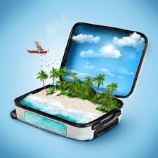

Your Job:

Plan a trip for you and a friend to Boston. You will be staying for the weekend. You will be flying this time, since driving isn’t an option.
We need a daily schedule, hotel, car, activites and food expense.
Your Budget:
You have a budget of $1,000 to cover the cost of travel, including renting a car, staying at a hotel, and meals. The money will also go towards the cost of resort admission, hotels,
and meals while at the destination. You can also use leftover funds for extra activities that will make the vacation extra special and fun.

Your Tasks:
- Choose a rental Car company and car to meet your needs
- Use a site for hotel or maybe even rent an apartment?
- Sightseeing and cost
- Food Expense

Your Materials:
- You will receive:
  - a Vacation Choices board to select options for the trip
  - a vacation cost chart to total travel costs (round trip), destination costs, and any extra activities/expenses
  - a blank sample daily schedule to show your clients what their vacation will be like
  - a rubric

Time to pack your bags!!
Let’s Plan our Trip and make our budget work!!
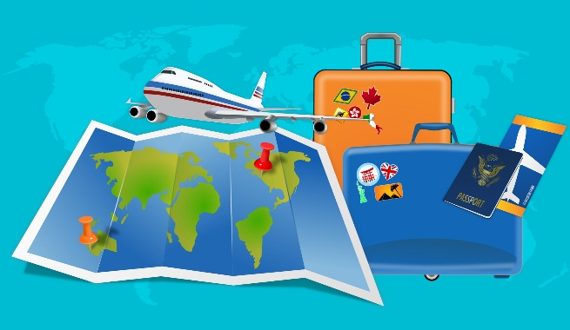

Vacation Choices
Travel Agents:
Item | A | B | C
Rental Car | Small 4 door car ($35/day) | Minivan or SUV ($60/day) | 2 door sports car ($50/day)
Regular  Travel Hotel | Superior Hotel-indoor &  outdoor pools, movies, TV, internet ($100/day) | Good Hotel-outdoor pool, TV ($70/night) | Average Hotel-TV ($50/night)
Regular  Travel Meals | Fast food for all meals ($20 per day per person) | Fast food for 2 meals and 1 meal at a nice restaurant ($40 per day per person) | Fast food for 1 meal and 2 meals at a nice restaurant ($60 per day per person)
Destination Hotel | Superior Hotel-huge pool, 4 restaurants, arcade, gym, 24 snack shop, shopping, internet, TV ($300/night) | Good Hotel-mid-size pool, 1 restaurant, gym, internet, TV ($200/night) | Average Hotel-small pool, restaurant, internet, TV ($100/night)
Destination Meals | Lunch and dinner at at selected restaurant (you do not choose) ($40 per person per day) | Lunch and dinner at any restaurant of your choice ($50 per person per day) | Breakfast, lunch, and dinner at any restaurant of your choice ($70 per person per day)
Destination Resort/Park | Hawaiian Beach Vacation Package-will take 2 days, 1 night to get there; includes scuba diving, snorkeling, surf lessons & more! ($200 per person) | Disneyland Package-will take 3  days, 2 nights to get there; includes famous rides, characters, 3D movies, & more! ($100 per person) | Camping Adventure Trip-will take 2 days, 1 night to get there; includes skiing, fishing, boating, obstacle courses, paint ball, & more! ($70 per person)
Flight:  Round Trip?  One Way and Drive back or there? | Round trip Flights are cheaper from major cities, however there could be travel expense to the major city that would need to be included | One Way tickets are nice for sightseeing you may want to see on the road either there or back. Book One Way and pick up a car | Explore all options while planning your trip. You may not to get to go again, so make it count!!

Vacation Cost Chart
Budget Amount: ____________ Dates Traveling____________________________

Travel Costs:
Flight | Number of Days | Number of Days X Cost Per Day | Total
Rental Car
Gas
Choice of Meals Refer to chart above | Number of Days (round trip) | Number of Days X Cost Per Person X Number of People | Total
Extra Hotels along the way??
Total Cost of Travel:
Choice of Extra Spending Options Sightseeing
Choice | Cost | Cost X number of People | Total

Choice of Extra Spending Options Sightseeing
Choice | Cost | Cost X Number of People | Total
Total Cost of Extra Spending Options
TOTAL TRIP COST (Total Cost of Travel + Total Destination Costs + Total Cost of Extra Spending Options

Notes:

Travel Agents: __________________________________________________________

Sample Daily Schedule

Day 1 Agenda
Activity |  | Starting Time | Ending Time | Cost/Travel
Total | Elapsed Time:

